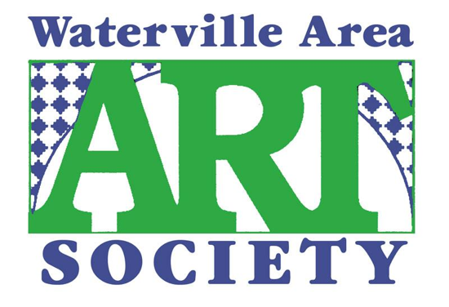
To apply, students must be nominated by their teacher and submit 3 photographs or video clips of their work along with their name and contact information to:

WAAS
PO Box 2703
Waterville, ME 04903-2703
or
waasmaine@gmail.com

Each year the Waterville Area Art Society awards one graduating senior from an area High School pursuing a degree in visual, performing arts, or music with a

$1,000 Scholarship!

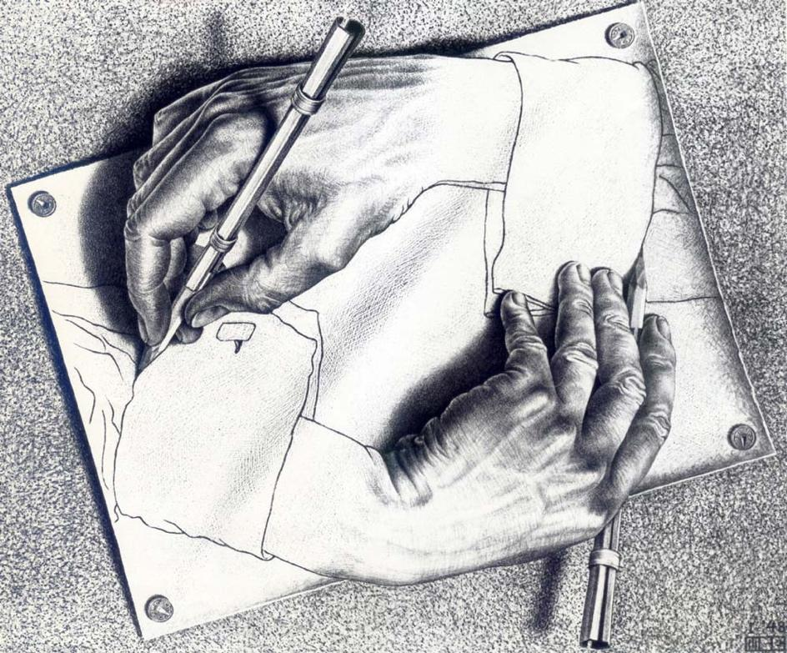

The Deadline is May 1st, 2024

High Schools eligible to enter include:
Waterville High School ● Winslow High School ● Lawrence High School ● Messalonskee High School ● Erskine Academy ● Mid-Maine Technical Center ● Temple Academy

