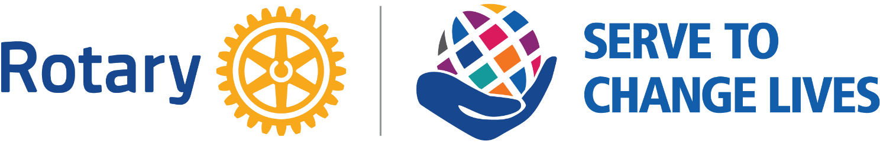

Waterville Sunrise Rotary Club
c/o Erin Conner, PO Box 1763, Waterville, ME 04903-1763
wtvlrotary@gmail.com | econner@connectedcreditunion.org

Scholarship Application
One scholarship of $500 renewable up to four years for a total of $2,000 will be awarded to a student from one of the high schools noted below. The winner will be notified by their Guidance Office. In order to receive their award, each year the student must: 1) provide evidence of having successfully completed the first semester as a full-time student in good standing at an accredited college, university, or technical school (passing grades in all subjects); and 2) provide evidence of enrollment as a full-time student for a second semester of post secondary school.

A further condition of this scholarship is that the second semester referenced above must begin within a year of the first semester.

Eligibility requirements are as follows:
- Be a graduating senior from central Maine.
- Acceptance to an accredited college, university, or technical school.
- Demonstration of financial need.
- Demonstrate passing grades in all subjects during your high school years.
- Participation in community service.

Student Name: _______________________________________________________________________

Name of High School: __________________________________________________________________

Name of School to which you have been accepted: __________________________________________

- Rotary’s 2022 theme is “SERVE TO CHANGE LIVES.” In an essay not to exceed 200 words, describe how you have exemplified CHANGING LIVES through your activities and service at school, church, and/or in your community.

- Please describe your high school scholastic activities, including all honors received and leadership positions you have held.

- Please describe briefly all other activities in which you are involved (sports, community service), whether through the school or other organizations e.g. church, scouting, 4H, etc. noting again all leadership positions you have held and/or awards or designations you have received.

- Briefly describe your financial need.

Please return the completed application to your Guidance Office or by email to wtvlrotary@gmail.com no later than May 25, 2022.

