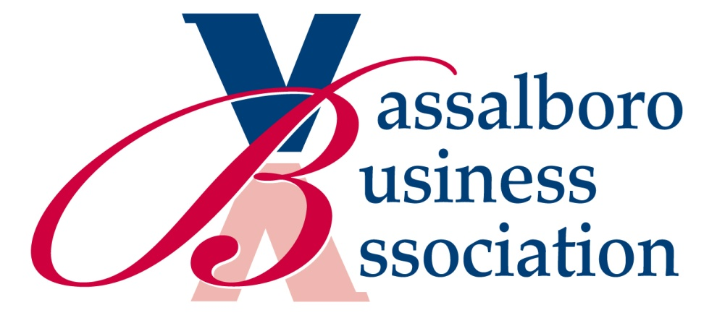
Vassalboro Business Association’s
$500.00 Scholarship for a Post-Secondary Program of Study
Recipient must have been a resident in Vassalboro for the past two years, provide evidence of community service in that same two year period, and be enrolled in a post-secondary two to four year program of education or training.
Name: ________________________________________________________________________
Street Address: ________________________________________________________________________
Town: ________________________________________________________________________
Phone: _____________________________ Email: _______________________________________
Where did/will you complete your high school education? _____________________ Year?_________
It is important for you to realize that the VBA scholarship reflects the value we place on community service experience. You MUST fill in the Community Service chart on the back side of this form or attach an equivalent to the application.

Please list two references who can verify your community service and their contact information.
Reference Name | Relationship/Position | Phone Number/email
1.

2.

What is your plan for your next level of study?
Winning recipients will be notified by May 15, 2021 At that time you will be asked to send us a picture that can be published in the local newspaper. The money will be sent directly to your college or post-high school program of study business office in August of 2021.
I certify that I have lived in Vassalboro for the last two years and that all information contained herein is true and accurate.
Signature: __________________________________________ Date: _______________________________
Please mail to VBA, P.O. Box 31, North Vassalboro, ME 04962
Submission deadline is April 15, 2021
Your Community Service In the last two years: (You may add pages if you wish)
Community service | Dates/Hours | What I learned from this experience

